**Tutorial 4 – Flashlight toggle**

* Start by creating an object in the camera of the First Person Player component and call it “Flashlight”. Reset its Transform and move it slightly forward, towards where the camera of the Player is facing.
* Now add a Spotlight to the Flashlight through the Hierarchy and make sure the light faces the same way as the camera. Adjust the colour and brightness to your liking

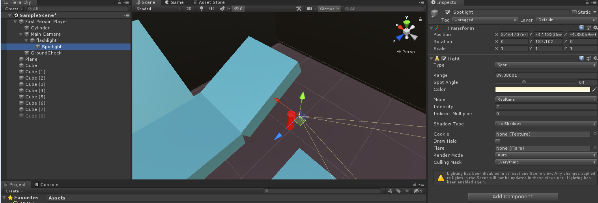

* Add a script in the Flashlight through the inspector and call it “FlashLight”
* Create a public GameObject in the script to be able to reference the flashlight withting the script
* 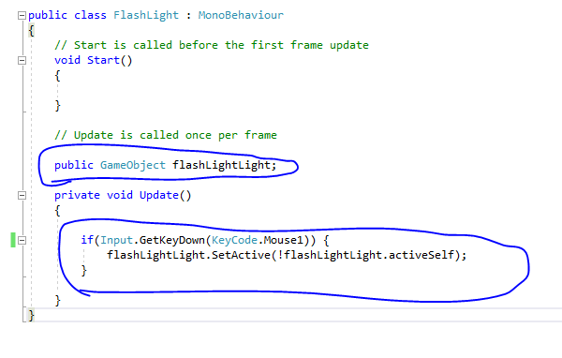Then create a private void update, which records when the chosen button (in this case the left mouse button) is pressed, and then activates or deactivated the spotlight. Make sure to reference the Spotlight in the Flash Light script in the Unity Inspector.